MD2201: Data Science

Name of the student: Nisha Modani Roll No. 66

Div: CS_B Batch: B3

Date of performance: 16-09-20

Experiment No.1

Title: Laboratory on Data Visualization
Aim: i. To explore the dataset for different case study examples with different commands.
ii. To plot the Box plot and scatter plot.

Software used: Programming language R.

Code Statement:
- Write a single R code to display the answers for the following questions.

Case Study: Consider the “pollutant” data set.

- What is the mean of “Temp” when “Month” is equal to 6?
- How many observations are there in the given data?
- Print last two rows of the data.
- What is the value of Ozone in 47th row?
- How many values are missing in Ozone column?
- What is the mean of Ozone column excluding missing values?
- Extract the subset of rows of the data frame where Ozone values are above 31 and Temp values are above 90. What is the mean of Solar.R in this subset?
- What was the maximum ozone value in the month of May (i.e. Month is equal to 5)?

- Write a single R code to display the answers the following questions

Case Study: Hair Eye color Data set

- How many people have brown eye color?
- How many people have Blonde hair?
- How many Brown haired people have Black eyes?
- What is the percentage of people with Green eyes?
- What percentage of people have red hair and Blue eyes?

- Write a single R code to display the answers the following questions

Case study: Germination Data Set

- What is the average number of seeds germinated for the uncovered boxes with level of watering equal to 4?
- What is the median value for the data covered boxes?

Establish conclusions on the basis of available data:
a. Association of levels of watering with the number of germinating seeds in case of covered boxes as well as uncovered boxes.
b. Association of number of germinating seeds with the fact that the boxes were covered or uncovered.

- Write a single R code to display the Boxplot for sepal length of iris data set. Also display the scatter plot between sepal length and sepal width of iris data set. Give proper title, x,y axis label etc. to the plot.

Code: (Write code for all above cases here)
CODE 1:
#get working directory
getwd()
# to change directory
setwd("C:/Users/HP/Desktop/Data science/Data Set for data visualization lab")
# to read data
d1<-read.csv("pollutant_csv.csv", header=T)

#1 What is the mean of “Temp” when “Month” is equal to 6?
m<-mean(d1$Temp[d1$Month==6])
cat("\nmean of temperatures in 6th month is: ",m)

#2 How many observations are there in the given data?
n<-nrow(d1)
cat("\nnumber of observations in the dataset are: ",n)

#3 Print last two rows of the data.
tail(d1,2)

#4 What is the value of Ozone in 47th row?
o<-d1[47,"Ozone"]
cat("\nvalue of ozone in 47th row is: ",o)

#5 How many values are missing in Ozone column?
mv<-sum(is.na(d1$Ozone))
cat("\nNo. of missing values in ozone column are: ",mv)

#6 What is the mean of Ozone column excluding missing values?
mean<-mean(d1$Ozone, na.rm=T)
cat("\nmean of ozone column excluding missing values is: ",mean)

#7 Extract the subset of rows of the data frame where Ozone values are above 31 and Temp values are above 90. What is the mean of Solar.R in this subset?
sub<-subset(d1,d1$Ozone>31 & d1$Temp>90)
mean_1<-mean(sub$Solar.R)
cat("\nmean of subset is: ",mean_1)

#8 What was the maximum ozone value in the month of May (i.e. Month is equal to 5)?
max<-max(d1$Ozone[d1$Month==5], na.rm=T)
cat("\nmaximum ozone value in month may is: ",max)

CODE 2:
setwd("C:/Users/HP/Desktop/Data science/Data Set for data visualization lab")
d2<-read.csv("hair_eye_color_csv.csv", header=T)
#1
s<-sum(d2$Eye.Color=="Brown")
cat("\nno. of people with brown eye color are: ",s)

#2
s1<-sum(d2$Hair.Color=="Blonde")
cat("\nno. of people with blonde hair color are: ",s1)

#3
s2<-sum(d2$Eye.Color=="Black" & d2$Hair.Color=="Brown")
cat("\nno. of people having black eye color and brown hair color are: ",s2)

#4
s3<-sum(d2$Eye.Color=="Green")/nrow(d2)*100
cat("\npercenatge of people with green eyes: ",s3)

#5
s4<-sum(d2$Eye.Color=="Blue" & d2$Hair.Color=="Red")/nrow(d2)*100
cat("\npercentage of people having red hair and Blue eyes: ",s4)

CODE 3:
setwd("C:/Users/HP/Desktop/Data science/Data Set for data visualization lab")

d3<-read.csv("germination_csv.csv", header=T)

#1
m<-mean(d3$germinated[d3$Box=="Uncovered" & d3$water_amt=="4"])
cat("average number of seeds germinated for the uncovered boxes with level of watering equal to 4 are: ",m)
#2
m1<-median(d3$germinated[d3$Box=="Covered"])
cat("median value for the data covered boxes is: ",m1)

CODE 4:
setwd("C:/Users/HP/Desktop/Data science/Data Set for data visualization lab")
d5<-read.csv("iris_data_csv.csv", header=T)

boxplot(d5$sepal.length~d5$Iris, main="box plot of iris data wrt length", xlab="x-axis", ylab="y-axis", col=c("red","green"))

boxplot(d5$sepal.width~d5$Iris, main="box plot of iris data wrt width", xlab="x-axis", ylab="y-axis", col=c("red","green"))

plot(d5$sepal.length,d5$sepal.width, main="Scatter plot of iris dataset", xlab="x-axis", ylab="y-axis", col=c("red","green"))

Results: Display the output obtained on R console for all the cases. Also add the plots which you obtained for 4th question above.

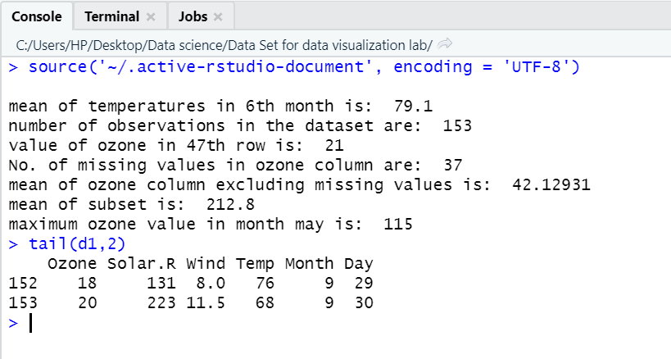

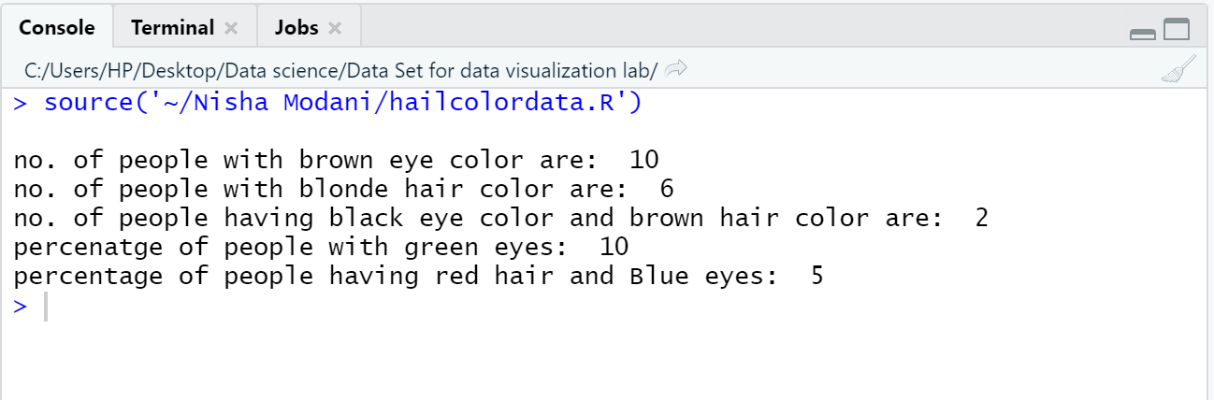

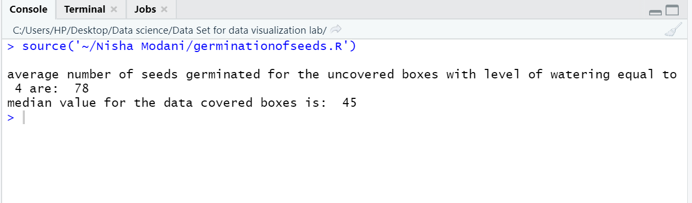

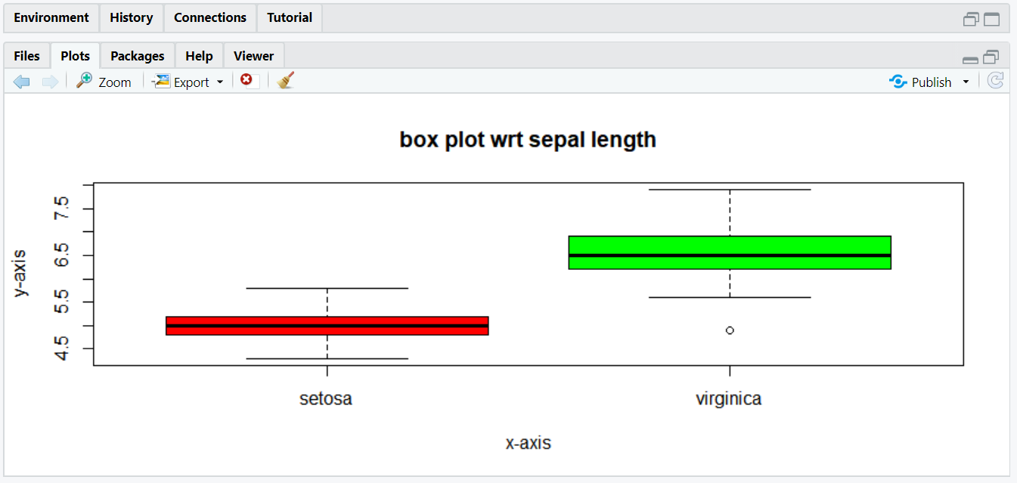

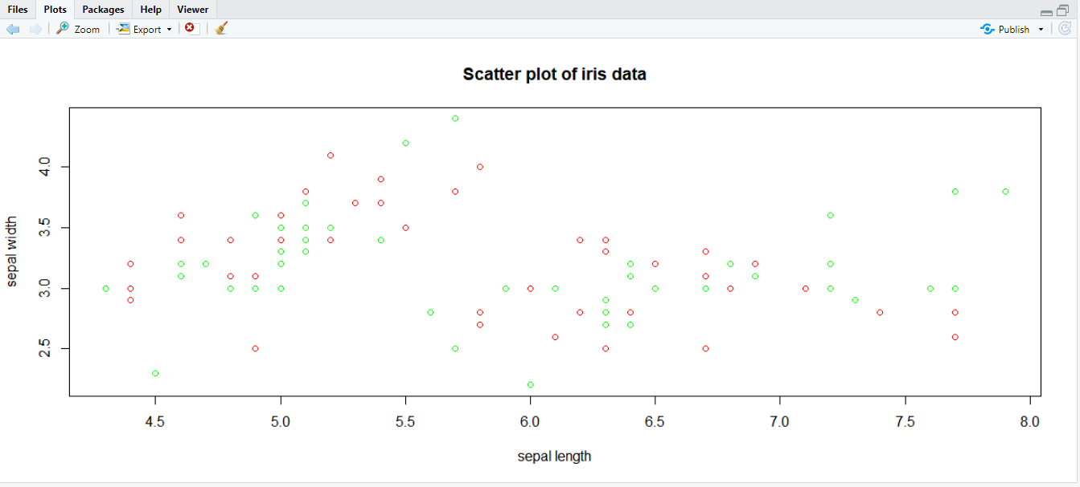

Conclusion: (Write the conclusion in your words).

Pollutant Dataset:

From this data set I have learnt to find mean, subset, and use various functions in R

The dataset contains total 153 rows

Learnt to use basic r functions like mean, sum, nrow, subset, max, min, etc

Hair & Eye Color Data Set

Dataset contains 21 rows along with headers

Learnt to find mean and number rows with double conditions.

From experiment we performed it is concluded that no. of people with brown eye color are 10, green eye color are 2, blue eye color are 5, and black eye color are 3

From experiment we performed it is concluded that no. of people with blonde hair color are 6, red hair color are 4, brown hair color are 7, and black hair color are 3

Germination of Seeds Data Set

Germination dataset contain 49 rows along with headers

In case of uncovered boxes as water level increases from 1 to 5 no. of germinated seeds increases with average no. of seeds germinated are 78 and in case of 6 water level germinated seeds are 0

In case of covered boxes as water level increases from 1 to 3 number of germinated seeds increases with average of 76 seeds and further when water level is increased no. of germinated seeds decrease and is are 0 t water level 6

When boxes are covered germination of seeds is more

Iris Data Set

In this case study we have plotted box plot and scatter plot

From box plot it is clear that outliers for setosa species are 4.3 and 5.8 median is 5 and outliers for virginica species are 5.7 and 7.7 and median is 6.5

From scatter plot is seen that there is no perfect relation between sepal length and sepal width of species

